**WEEK 4: SPRING REST USING SPRING BOOT**

1. **Spring-rest-handson**

**Hands on 1**

**Create a Spring Web Project using Maven**

**Code:**

**SpringLearnApplication.java**

package com.cognizant.springlearn;

import org.springframework.boot.SpringApplication;

import org.springframework.boot.autoconfigure.SpringBootApplication;

@SpringBootApplication

public class SpringLearnApplication {

public static void main(String[] args) {

SpringApplication.run(SpringLearnApplication.class, args);

System.out.println("SpringLearnApplication started...");

}

}

**pom.xml**

<project xmlns="http://maven.apache.org/POM/4.0.0"

xmlns:xsi="http://www.w3.org/2001/XMLSchema-instance"

xsi:schemaLocation="http://maven.apache.org/POM/4.0.0

http://maven.apache.org/xsd/maven-4.0.0.xsd">

<modelVersion>4.0.0</modelVersion>

<groupId>com.cognizant</groupId>

<artifactId>spring-learn</artifactId>

<version>0.0.1-SNAPSHOT</version>

<packaging>jar</packaging>

<name>spring-learn</name>

<description>Spring Boot Learning Project</description>

<parent>

<groupId>org.springframework.boot</groupId>

<artifactId>spring-boot-starter-parent</artifactId>

<version>3.1.2</version>

<relativePath/>

</parent>

<properties>

<java.version>17</java.version>

</properties>

<dependencies>

<dependency>

<groupId>org.springframework.boot</groupId>

<artifactId>spring-boot-starter</artifactId>

</dependency>

<dependency>

<groupId>org.springframework.boot</groupId>

<artifactId>spring-boot-starter-test</artifactId>

<scope>test</scope>

</dependency>

</dependencies>

<build>

<plugins>

<plugin>

<groupId>org.springframework.boot</groupId>

<artifactId>spring-boot-maven-plugin</artifactId>

</plugin>

</plugins>

</build>

</project>

**Output:**

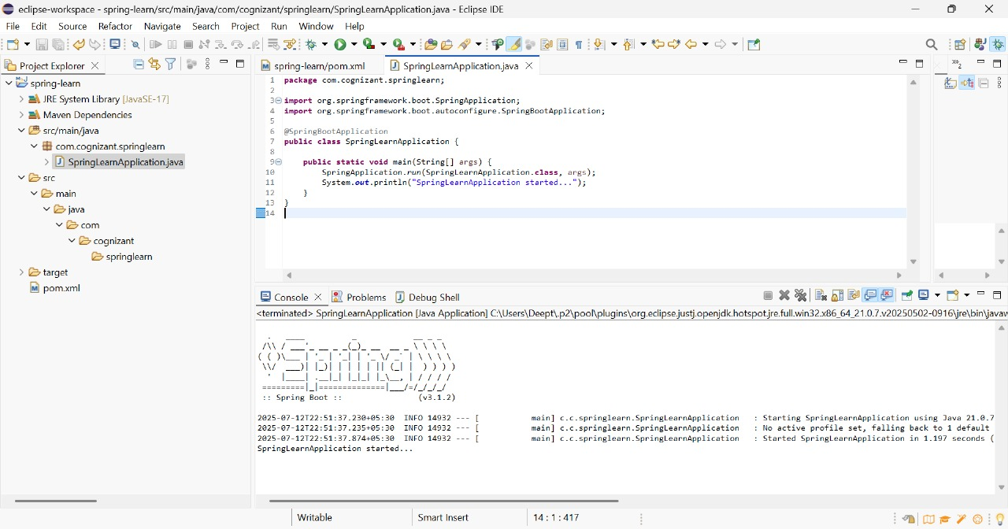

**Hands on 2**

**Spring Core – Load SimpleDateFormat from Spring Configuration XML**

Code:

SpringLearnApplication.java

package com.cognizant.springlearn;

import java.text.ParseException;

import java.text.SimpleDateFormat;

import java.util.Date;

import org.springframework.context.ApplicationContext;

import org.springframework.context.support.ClassPathXmlApplicationContext;

import org.springframework.boot.SpringApplication;

import org.springframework.boot.autoconfigure.SpringBootApplication;

@SpringBootApplication

public class SpringLearnApplication {

public static void main(String[] args) {

SpringApplication.run(SpringLearnApplication.class, args);

System.out.println("SpringLearnApplication started...");

displayDate(); // call the method

}

public static void displayDate() {

ApplicationContext context = new ClassPathXmlApplicationContext("date-format.xml");

SimpleDateFormat format = context.getBean("dateFormat", SimpleDateFormat.class);

try {

Date date = format.parse("31/12/2018");

System.out.println("Parsed Date: " + date);

} catch (ParseException e) {

e.printStackTrace();

}

}

}

**date-format.xml**

<?xml version="1.0" encoding="UTF-8"?>

<beans xmlns="http://www.springframework.org/schema/beans"

xmlns:xsi="http://www.w3.org/2001/XMLSchema-instance"

xsi:schemaLocation="http://www.springframework.org/schema/beans

https://www.springframework.org/schema/beans/spring-beans.xsd">

<bean id="dateFormat" class="java.text.SimpleDateFormat">

<constructor-arg value="dd/MM/yyyy" />

</bean>

</beans>

**Output:**

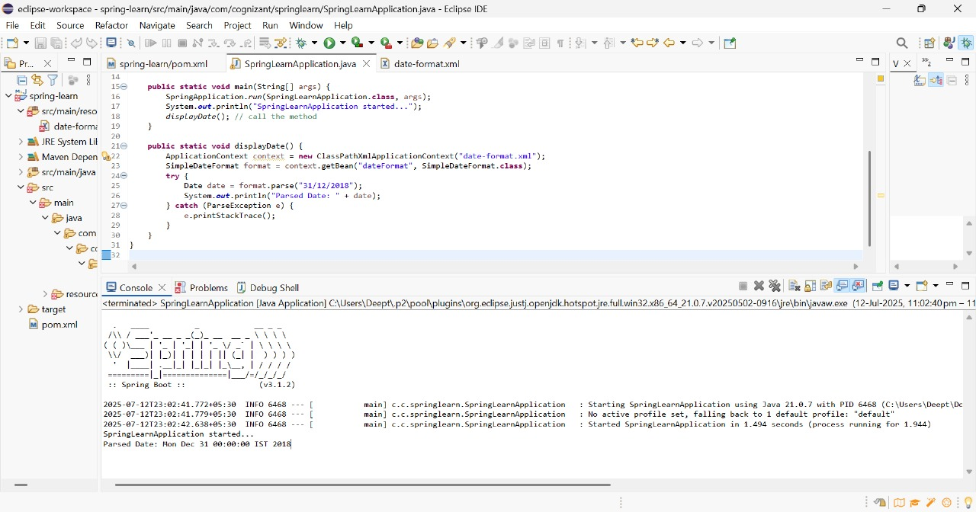

**Hands on 3**

**Spring Core - Incorporate Logging**

SpringLearnApplication.java

package com.cognizant.springlearn;

import org.slf4j.Logger;

import org.slf4j.LoggerFactory;

import org.springframework.context.ApplicationContext;

import org.springframework.context.support.ClassPathXmlApplicationContext;

import org.springframework.boot.SpringApplication;

import org.springframework.boot.autoconfigure.SpringBootApplication;

import java.text.SimpleDateFormat;

import java.util.Date;

@SpringBootApplication

public class SpringLearnApplication {

private static final Logger LOGGER = LoggerFactory.getLogger(SpringLearnApplication.class);

public static void main(String[] args) {

LOGGER.info("START");

SpringApplication.run(SpringLearnApplication.class, args);

SpringLearnApplication app = new SpringLearnApplication();

app.displayDate();

LOGGER.info("END");

}

public void displayDate() {

LOGGER.info("displayDate() START");

ApplicationContext context = new ClassPathXmlApplicationContext("date-format.xml");

SimpleDateFormat format = context.getBean("dateFormat", SimpleDateFormat.class);

try {

Date date = format.parse("31/12/2018");

LOGGER.debug("Date Parsed: {}", date);

} catch (Exception e) {

LOGGER.error("Error parsing date", e);

}

LOGGER.info("displayDate() END");

}

}

**date-format.xml**

<?xml version="1.0" encoding="UTF-8"?>

<beans xmlns="http://www.springframework.org/schema/beans"

xmlns:xsi="http://www.w3.org/2001/XMLSchema-instance"

xsi:schemaLocation="http://www.springframework.org/schema/beans

https://www.springframework.org/schema/beans/spring-beans.xsd">

<bean id="dateFormat" class="java.text.SimpleDateFormat">

<constructor-arg value="dd/MM/yyyy"/>

</bean>

</beans>

**application.properties**

logging.level.org.springframework=info

logging.level.com.cognizant.springlearn=debug

logging.pattern.console=%d{yyMMdd}|%d{HH:mm:ss.SSS}|%-20.20thread|%5p|%-25.25logger{25}|%25M|%m%n

**Output:**

